**Bootstrap Grid Classes**

* Grid is designed by using the classes
  + .row
  + .col
* They provide responsive grid design.

**Defining a row:** You can define a row in grid system by using the following classes.

|  |  |
| --- | --- |
| **Class Name** | **Description** |
| .row | Single row |
| .row-cols-number | The number of columns in row. |
| .row-cols-sm-number | For small screen |
| .row-cols-md-number | For medium screen |

Note: Row number can be defined only from 1 to 6.

**Defining a column:** You can define a column in grid system by using the following classes.

|  |  |
| --- | --- |
| **Class** | **Description** |
| .col | It specifies a column |
| .col-sm | 540px [mobile] |
| .col-md | 720px [tab] |
| .col-lg | 960px [laptop] |
| .col-xl | 1140px [desktop] |

Note: In a grid system you can defined columns range from 1 to 12 only.

col-3 30% of browser

col-9 70% of browser

col-12 100% of browser

You can use responsive according to device.

Col-sm-3

Col-lg-3

Col-md-3

Ex:

<!DOCTYPE html>

<html>

<head>

<title>Demo</title>

<link rel="stylesheet" href="../node_modules/bootstrap/dist/css/bootstrap.css">

<style>

.col-3 {

border-right: 2px solid;

}

.col-2{

border-right: 2px dotted;

}

</style>

</head>

<body class="container-fluid">

<h2>Product Details</h2>

<dl class="row">

<dt class="col-2">Name</dt>

<dd class="col-10">Samsung TV</dd>

<dt class="col-2">Price</dt>

<dd class="col-10">&#8377; 45600.44</dd>

<dt class="col-2">Stock</dt>

<dd class="col-10">Available</dd>

<dt class="col-2">Shipped To</dt>

<dd class="col-10">Delhi</dd>

</dl>

<div class="row">

<div class="col-3">

<p class="text-justify">Depending on how you obtained the Windows software, this is a license agreement between (i) you and the device manufacturer or software installer that distributes the software with your device; or (ii) you and Microsoft Corporation (or, based on where you live or, if a business, where your principal place of business is located, one of its affiliates) if you acquired the software from a retailer.</p>

</div>

<div class="col-9">

<p>Depending on how you obtained the Windows software, this is a license agreement between (i) you and the device manufacturer or software installer that distributes the software with your device; or (ii) you and Microsoft Corporation (or, based on where you live or, if a business, where your principal place of business is located, one of its affiliates) if you acquired the software from a retailer.</p>

<p>Depending on how you obtained the Windows software, this is a license agreement between (i) you and the device manufacturer or software installer that distributes the software with your device; or (ii) you and Microsoft Corporation (or, based on where you live or, if a business, where your principal place of business is located, one of its affiliates) if you acquired the software from a retailer.</p>

<p>Depending on how you obtained the Windows software, this is a license agreement between (i) you and the device manufacturer or software installer that distributes the software with your device; or (ii) you and Microsoft Corporation (or, based on where you live or, if a business, where your principal place of business is located, one of its affiliates) if you acquired the software from a retailer.</p>

</div>

</div>

</body>

</html>

Ex: Layout with rows and cols

<!DOCTYPE html>

<html>

<head>

<title>Layout</title>

<link rel="stylesheet" href="../node_modules/bootstrap/dist/css/bootstrap.css">

<link rel="stylesheet" href="../Fonts/css/all.css">

<style>

.container-fluid {

width: 90%;

}

#header, #footer {

background-color: darkcyan;

color:white;

text-align: center;

}

#section {

height: 500px;

}

.col-2{

border-right: 3px solid darkcyan;

}

</style>

</head>

<body class="container-fluid">

<div class="row" id="header">

<div class="col">

<h1><span class="fa fa-shopping-cart"></span> Amazon Shopping</h1>

</div>

</div>

<div class="row" id="section">

<div class="col-2">

<ul>

<li>Home</li>

<li>Electronics</li>

<li>Footwear</li>

</ul>

</div>

<div class="col-7">

<h2>Amazon Home</h2>

<img src="../Images/shoe.jpg" width="100" height="100">

<img src="../Images/jblspeaker.jpg" width="100" height="100">

<img src="../Images/jeans.jpg" width="100" height="100">

</div>

<div class="col-3">

<h2>Your Cart Summary</h2>

<dl class="row">

<dt class="col-sm-4">Total Items</dt>

<dd class="col-sm-8">3</dd>

<dt class="col-sm-4">Total Amount</dt>

<dd class="col-sm-8">&#8377; 4500.00</dd>

</dl>

</div>

</div>

<div class="row" id="footer">

<div class="col">

<div class="text-center">

&copy; copyright 2020

</div>

</div>

</div>

</body>

</html>

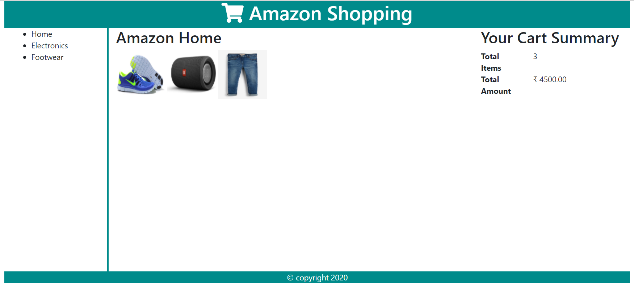

**Bootstrap Colors**

* Bootstrap provides pre-defined class for background, foreground, border.
* The bootstrap contextual colors:
  + Primary
  + Secondary
  + Dark
  + Light
  + Success
  + Warning
  + Danger
  + Info etc.
* If you want color for text (foreground) you can use “text-contextual”
  + .text-primary
  + .text-secondary
  + .text-dark
  + .text-success etc.
* If you want color for background you can use “bg-contextual”
  + .bg-primary
  + .bg-secondary
  + .bg-dark
  + .bg-danger etc.
* If you want color for border you can use “border-contextual”
  + .border-primary
  + .border-danger etc.

Syntax:

<!DOCTYPE html>

<html>

<head>

<title>Colors</title>

<link rel="stylesheet" href="../node_modules/bootstrap/dist/css/bootstrap.css">

<style>

#box {

margin-top: 10px;

}

</style>

</head>

<body class="container-fluid">

<div class="text-primary">Primary</div>

<div class="text-secondary">Secondary</div>

<div class="text-dark">Dark</div>

<div class="text-warning">Warning</div>

<div class="text-danger">Danger</div>

<h2>Backgrounds</h2>

<div class="text-light">

<div class="bg-primary">Primary</div>

<div class="bg-secondary">Secondary</div>

<div class="bg-dark">Dark</div>

<div class="bg-warning">Warning</div>

<div class="bg-danger">Danger</div>

</div>

<h2>Borders</h2>

<div class="text-primary">

<div id="box" class="border border-primary">Primary</div>

<div id="box" class="border border-secondary">Secondary</div>

<div id="box" class="border border-dark">Dark</div>

<div id="box" class="border border-warning">Warning</div>

<div id="box" class="border border-danger">Danger</div>

</div>

</body>

</html>

Ex:

<!DOCTYPE html>

<html>

<head>

<title>Layout</title>

<link rel="stylesheet" href="../node_modules/bootstrap/dist/css/bootstrap.css">

<link rel="stylesheet" href="../Fonts/css/all.css">

<style>

.container-fluid {

width: 90%;

}

#section {

height: 500px;

}

.col-2{

border-right: 3px solid darkcyan;

}

</style>

</head>

<body class="container-fluid">

<div class="row bg-info text-light text-center border border-danger" id="header">

<div class="col">

<h1><span class="fa fa-shopping-cart"></span> Amazon Shopping</h1>

</div>

</div>

<div class="row" id="section">

<div class="col-2">

<ul>

<li>Home</li>

<li>Electronics</li>

<li>Footwear</li>

</ul>

</div>

<div class="col-7">

<h2>Amazon Home</h2>

<img src="../Images/shoe.jpg" width="100" height="100">

<img src="../Images/jblspeaker.jpg" width="100" height="100">

<img src="../Images/jeans.jpg" width="100" height="100">

</div>

<div class="col-3">

<h2>Your Cart Summary</h2>

<dl class="row">

<dt class="col-sm-4">Total Items</dt>

<dd class="col-sm-8">3</dd>

<dt class="col-sm-4">Total Amount</dt>

<dd class="col-sm-8">&#8377; 4500.00</dd>

</dl>

</div>

</div>

<div class="row" id="footer">

<div class="col">

<div class="bg-info text-light text-center">

&copy; copyright 2020

</div>

</div>

</div>

</body>

</html>